**Design**

Contents

Design 12

High Level System Overview 12

ISPO 13

Inputs 13

Processes 14

Storage 14

Output 14

ERD Diagrams 14

Data Dictionary 15

Class Diagrams 18

System Flowchart 19

Hierarchy Chart 21

Key Formula and Equations 21

BMI Body Mass Index 21

Kilogram to Pound Conversion (Metric System to Imperial System) 21

Change in Weight 21

Algorithm Designs 22

Hand Written Pseudocode Algorithm Design 22

PHP Implemented Algorithm Design 25

SQL Queries and Explanations 31

Data Structures 32

Design Pre - Implementation 33

CRC Cards – Creating Classes 33

Final Design User Interface and Explanation 34

Log In Page 34

Register Page 34

Routines 35

Profile 35

Timetable (in development) 36

Search 36

Naming Conventions 36

Hardware Selection / Design 37

Visual Design on Phone (Nexus 5X) 37

System Security 38

Integrity of Data 39

# Design

## High Level System Overview

My gym website is structured around the user inputting data into a database, in the form of personal details, feedback and search parameters (to name a few), and the user receiving specific output, such as personalised routines, timetables and other information. This diagram above gives a simplified high-level abstraction of my website.

By splitting my system design into stages, it will allow me to split my workload into appropriate sections.

**Stage 1: System background**

The first stage of my design is to create a basic login system, which connects the user to the database and stores their details. In addition in this step, I will decide on the main visual design of my website, e.g colour scheme, headings, side bars.

* Log In System
  + Create User Class that holds user data
  + Create methods in user class that allows for Log In and Log Out, ensuring that session is created, destroyed and unset.
  + Hashing of data
  + SQl statements
* Visual Design
  + HTML
  + CSS
  + Links between other pages

**Stage 2: Creation of Routine and Exercise Classes**

The second stage of my design is creating the Routine Class and Exercise Class, these classes must be first constructed as they hold data relating to routine and exercises. *Please refer to my class diagrams.*

* Routine Class
  + Must hold data: Routine Name, Exercises
  + Composition Aggregation: Exercise Class instantiated within routine class
  + Feedback Button
* Exercise Class
  + Holds exercise specific data

**Stage 3: Creation of feedback system**

The third stage of my design will be to create the methods in the routine and exercise class, which will allow for the input, process of feedback and output (suggested weight).

* Input feedback: Need to take in user input after every set in a exercise
* Process Feedback:
  + Need to determine whether routine has been performed before, if so, it uses past feedback to generate a suggested weight.
  + Uses feedback inputted during routine, from Set 1 and Set 2, to create a suggested weight for Set 2 and Set 3 respectively (assuming there are 3 sets).

**Stage 4: Design other user functionality**

My final step will be to design and create the other aspects of user functionality, which requires the creation of the routine, exercise class.

* Timetable: Shows a weekly timetable, which can be adapted by user
* Search: Allows user to search for routine
* Create: Allows user to create routine
* Log: Allows user to see their past history of performed routines, and its associated data e.g rating.

## ISPO

### Inputs

* **Log In:** Email, Password
* **Register:** First Name, Last Name, Email, Password
* **Profile:** Old Password, New Password
* **Log:** Height, Weight
* **Performing Routine:** Feedback values (through a drop down list) for every set and rating
* **Timetable:** Date, Time, Routine
* **Search:** Search Parameters(Rating, Key Words, Muscle Group, Most Recently Performed)
* **Create:** Exercise Details (Name, sets, reps, order in routine, rest times)

Inputs into the system will be done through several medium

* Clicking on buttons, e.g going between pages, submitting a form
* Typing
* Choosing from drop down list

### Processes

* Registering -> Creating a new user
* Checking if user is logged in
* Logging out -> destroying session
* Changing user’s password -> double entry confirmation
* Upload profile picture to database
* Timetable -> generates template of timetable -> if user inputs or removes routine from their timetable it will show in the template
  + If routine is present: displays name of routine and muscles trained (ensuring no repeats)
  + Display add/remove routine button
* Printing Routine in human readable format
* Inputting a workout into database and its relevant data
* Feedback (complex algorithm) will provide a suggestion to the next set AND provide a suggestion for the next time the user performs the same routine (for the first set)
* Rating is stored in rating table, which can provide data (such as average rating) when searching

### Storage

* All data will be stored in the database: user details, routines, exercises, admin information
* Main Tables are
  + Routine Table
  + Exercise Table
  + Timetable Table
  + User Table
  + Feedback Table
  + Muscle Table
  + Exercise Table

### Output

* Display user information and profile detail
* The display of the routine, including exercise details, sets, reps, rest periods, feedback and suggestions
* Timetable: days of the week, time and routine (if any)
* Error Messages to users or confirmation messages
* Visual display of the website, including html and css

## ERD Diagrams

Using Lucid Charts, I have created the entity relationship diagram

Primary Key

*Foreign Key*

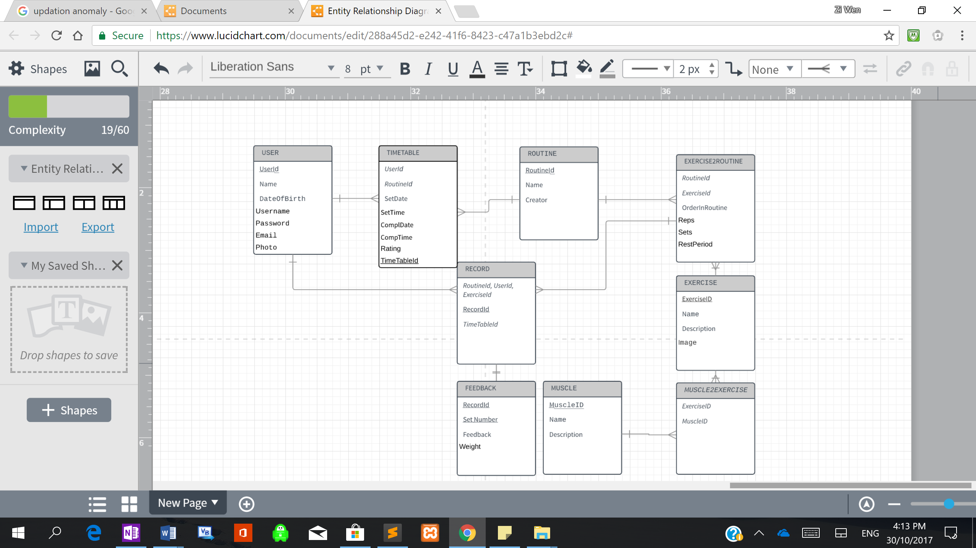

## Data Dictionary

|  |  |  |  |  |  |
| --- | --- | --- | --- | --- | --- |
| User | | | | | |
| Field Name | Data Type | Example Data | Length | Validation | Description |
| UserId | Integer | 1 | 20 | n/a | Primary key for users |
| Email | VarChar | gymguy@gym.com | 50 | Presence Check | Acts as the unique identifier which identifies the user during a log in |
| Password | VarChar | ***** | 50 | Double entry  +  Old Password | An encrypted set of characters that allows users to enter their user profile. It is encrypted when stored into database. |
| User Details (Name, DateOfBirth, Photo) | Name – VarChar  DateOfBirth – Date  Photo-VarChar |  | 50  10  50 |  | User details will be stored into database, and retrived to display a user profile. |

|  |  |  |  |  |  |
| --- | --- | --- | --- | --- | --- |
| Timetable | | | | | |
| Field Name | Data Type | Example Data | Length | Validation | Description |
| UserId  RoutineId  SetDate  Set Time | Integer  Integer  Date  Time | 1  42  13/12/17  01:30 | 20  20  10  5 | n/a | These 4 attributes (of which 2 are foreign keys) will form a primary composite key, identifying each unique session of when a user performs a routine. |
| ComplDate  ComplTime | Date  Time | 03/04/17  40 minutes | 8  10 | Type Check | These are simply stored to determine if a routine has been completed, and if so how long did it take. This 2 pieces of data may be used to find out average time taken and amount of times routines have been performed. |
| Rating | Integer | 9/10 | 2 | Range Check  Between 0 and 10 | This rating is given by the user and put into the database, so an average rating can be calculated.  *As the average rating is a calculated field, it will not be stored in database, rather it can be calculated on the go with an sql statement. (this is needed when searching)* |
|  |  |  |  |  |  |

|  |  |  |  |  |  |
| --- | --- | --- | --- | --- | --- |
| Routine | | | | | |
| Field Name | Data Type | Example Data | Length | Validation | Description |
| RoutineId | Integer | 34 | 6 | n/a | Unique id for routines |
| Name | VarChar | Leg Day | 50 | n/a |  |
| Creator | VarChar | Arnold | 50 | n/a |  |
|  |  |  |  |  |  |

|  |  |  |  |  |  |
| --- | --- | --- | --- | --- | --- |
| Exercise2Routine | | | | | |
| Field Name | Data Type | Example Data | Length | Validation | Description |
| *RoutineId*  *ExerciseId* | Integer | 34  54 | 6 | n/a | A primary composite key that uniquely identifies a routine and its exercise |
| OrderinRoutine | Integer | 3 | 2 | Type Check | Determine position of exercise in routine |
| Sets  Reps | Integer | 3  10 | 3 | Type Check |  |
| Rest Period | Integer | 30 seconds | 4 | Type Check |  |

|  |  |  |  |  |  |
| --- | --- | --- | --- | --- | --- |
| Exercise | | | | | |
| Field Name | Data Type | Example Data | Length | Validation | Description |
| ExerciseId | Integer | 5 | 10 |  | Uniquely identifies exercise id |
| Name | VarChar | Dumbbell Curl | 50 |  |  |
| Description | VarChar | Keep elbow locked and flex your bicep | 200 |  |  |
| Image | VarChar |  |  |  |  |

|  |  |  |  |  |  |
| --- | --- | --- | --- | --- | --- |
| Record | | | | | |
| Field Name | Data Type | Example Data | Length | Validation | Description |
| RecordId  *RoutineId, UserId, ExerciseId* | Integer | 1  14  25  36 | 5 | N/A | RecordId will consist of 3 foreign keys, which uniquely identifies a user doing a certain exercise in a routine. |
| Date | Date | 1/1/10 | 8 | Type Check | Stores the time when the exercise and routine was performed |

|  |  |  |  |  |  |
| --- | --- | --- | --- | --- | --- |
| Feedback | | | | | |
| Field Name | Data Type | Example Data | Length | Validation | Description |
| RecordId | Integer | 12 | 6 | n/a | This foreign key along with the Set Number attribute, will form a primary composite key, that will help uniquely identify the feedback and weight of a single set. |
| Set Number | Integer | 2 | 6 | n/a |
| Feedback | Varchar | Easy, Challenging, Too Difficult | 50 | Type Check +  Presence Check | Provides 3 options as shown.  Depending on the feedback and the reps, a suggested weight will be produced. |
| Weight | Integer | 10kg | 5 | Type Check + Presence Check | Weight inputted by user  *Suggested Weight, which is calculated by the User’s previous feedback and weight, is not stored in database because it is a calculated field.* |

|  |  |  |  |  |  |
| --- | --- | --- | --- | --- | --- |
| Muscle2Exercise | | | | | |
| Field Name | Data Type | Example Data | Length | Validation | Description |
| *ExerciseId*  *MuscleId* | Integer | 1 (Squats)  1 (Quadriceps) | 3 | n/a | A composite primary key that matches the muscle to a exercise. |
|  |  |  |  |  |  |

|  |  |  |  |  |  |
| --- | --- | --- | --- | --- | --- |
| Muscle | | | | | |
| Field Name | Data Type | Example Data | Length | Validation | Description |
| MuscleId | Integer | 3 | 5 | n/a |  |
| Name | VarChar | Dumbbell Lateral Raise | 20 | n/a |  |
| Description | VarChar | Hold the dumbbell with a pronated grip, and lift it by your side up to your shoulder height. | 50 | n/a |  |
|  |  |  |  |  |  |

## Class Diagrams

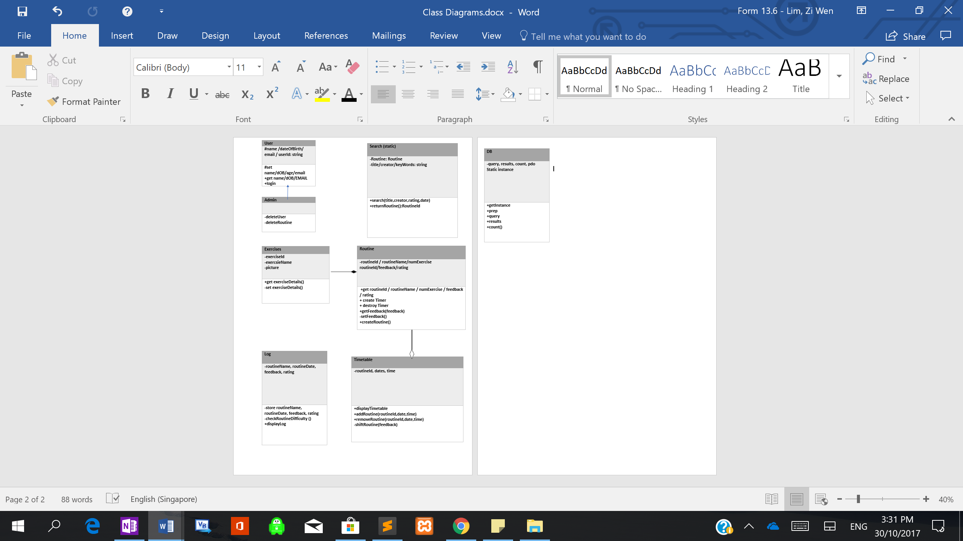

## System Flowchart

|  |  |
| --- | --- |
| **Process** | **Flow Chart** |
| **Login System** | https://documents.lucidchart.com/documents/82d20396-c66b-4acb-9b6d-d7f992de4922/pages/0_0?a=403&x=65&y=131&w=1210&h=638&store=1&accept=image%2F*&auth=LCA%2072851a0eb2fd83a8ab7491f4f99e1b70282d5a2b-ts%3D1508294633 |
| **Searching Routine** | https://documents.lucidchart.com/documents/82d20396-c66b-4acb-9b6d-d7f992de4922/pages/a_uGPxO_AKyi?a=728&x=577&y=243&w=506&h=814&store=1&accept=image%2F*&auth=LCA%20ad4ae6df2d261a35b8857104b8a714aec6bb83d3-ts%3D1508294633 |
| **Displaying Routine** | https://documents.lucidchart.com/documents/82d20396-c66b-4acb-9b6d-d7f992de4922/pages/0_0?a=1301&x=531&y=114&w=641&h=1012&store=1&accept=image%2F*&auth=LCA%2073486f929902eae615efec76324ab06c37ea75f7-ts%3D1508295618 |
| **Performing Routine** | https://documents.lucidchart.com/documents/8af8c6fb-6500-451d-98c9-eba478a5f9b7/pages/0_0?a=432&x=392&y=-48&w=553&h=1056&store=1&accept=image%2F*&auth=LCA%201167ceb3971b1c515458897f1c172c76a2ae0d8d-ts%3D1508296358 |
| **Generate TimeTable** | https://documents.lucidchart.com/documents/8af8c6fb-6500-451d-98c9-eba478a5f9b7/pages/0_0?a=833&x=376&y=77&w=842&h=936&store=1&accept=image%2F*&auth=LCA%2000c8edb75a8c4818f2a0efdd248db03ddcea7814-ts%3D1508297031 |

## Hierarchy Chart

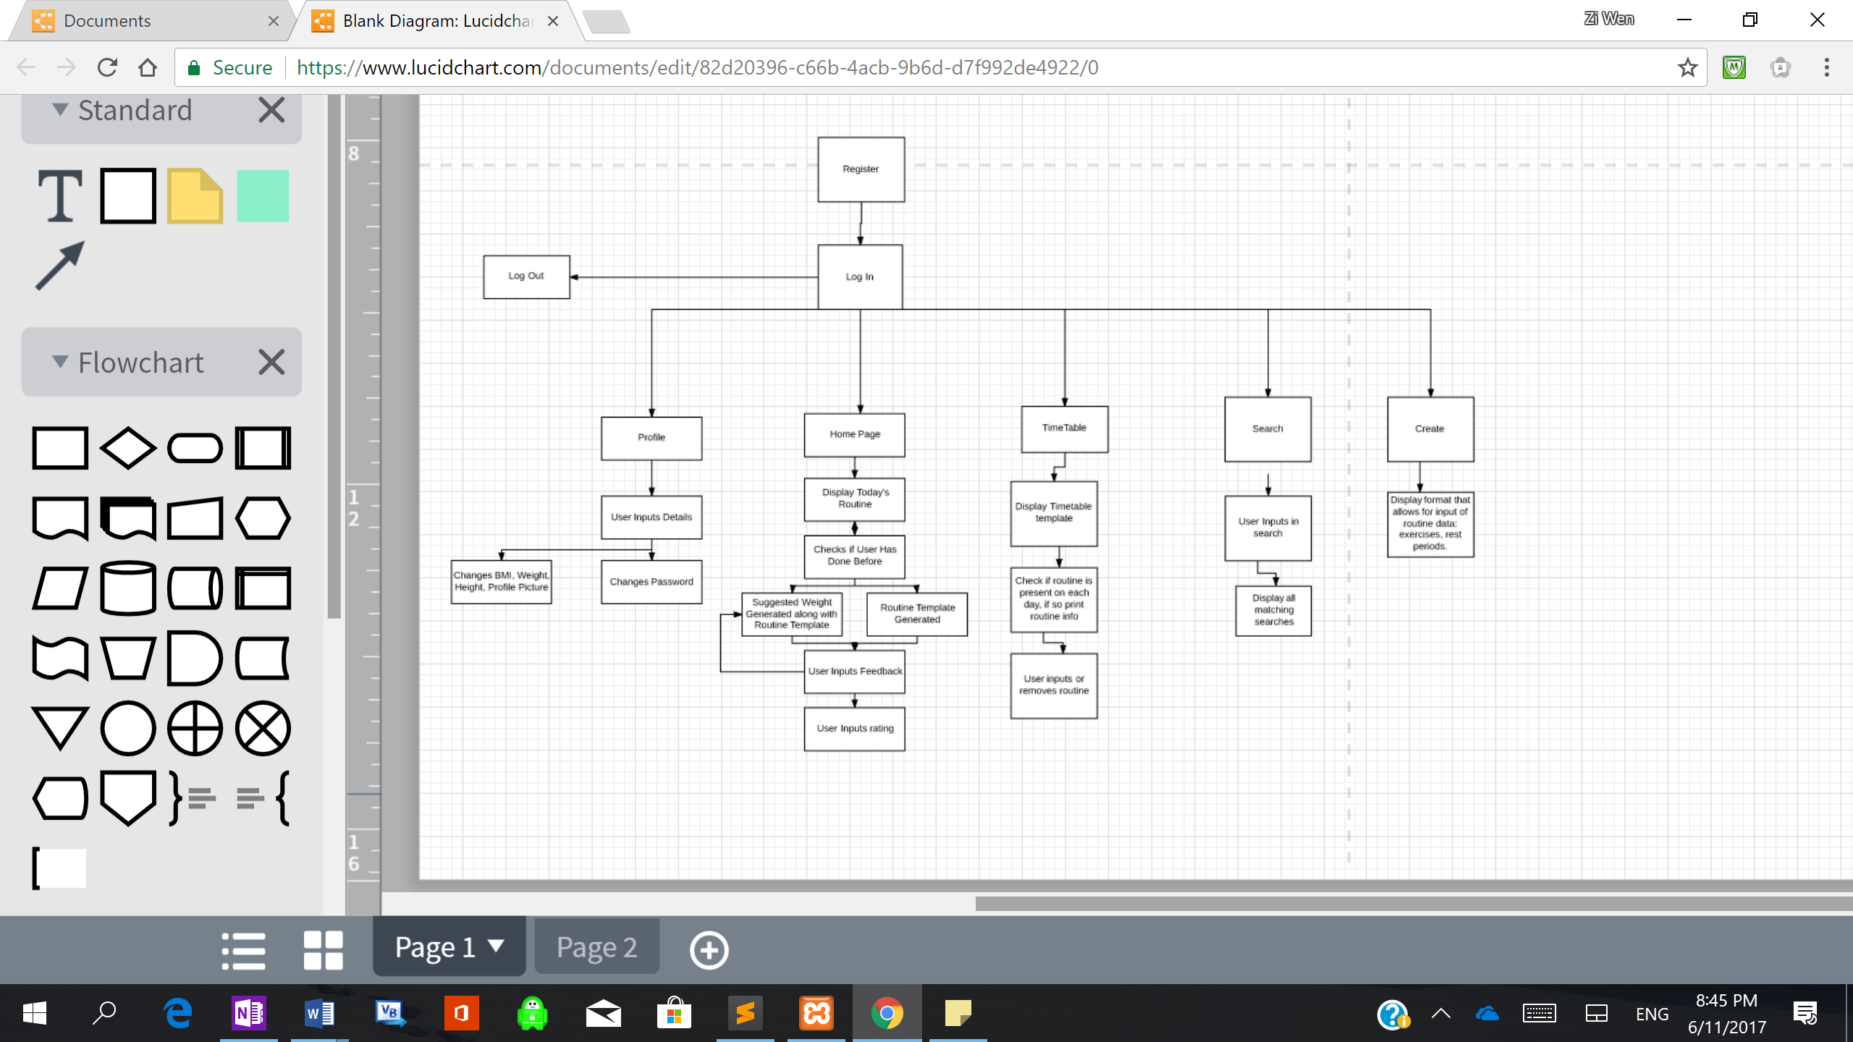

## Key Formula and Equations

### BMI Body Mass Index

An approximate measure of whether someone is over/underweight, used to estimate fat percentage.

**Weight / Height*Height**

*Please note that BMI is simply an approximation for the general population, it is not an accurate indication of fat percentage for people with extreme body types, such as those of athletes.*

### Kilogram to Pound Conversion (Metric System to Imperial System)

1 kg = 2.2 lbs

*If in the gym, a rough approximation of multiplication/division of 2 can be accurate for lower weights*

### Change in Weight

* If rep range below 6, weight increases by 5kg
* If rep range above 6, weight increases by 2.5kg
* If too difficult, weight decreases by 2.5kg, regardless of rep range, this is to ensure progressive overload can still occur without overtraining.

## Algorithm Designs

### Hand Written Pseudocode Algorithm Design

|  |
| --- |
| Hand drawn design of what my timetable should look like, prior to implantation. |

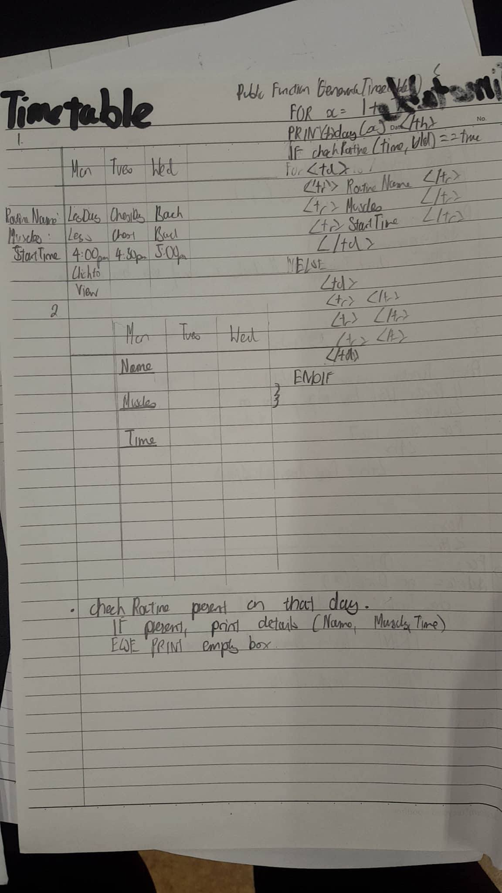

|  |
| --- |
| Initial hand written plan of the feedback system.  I followed scenario 1, rather than scenario 2. |

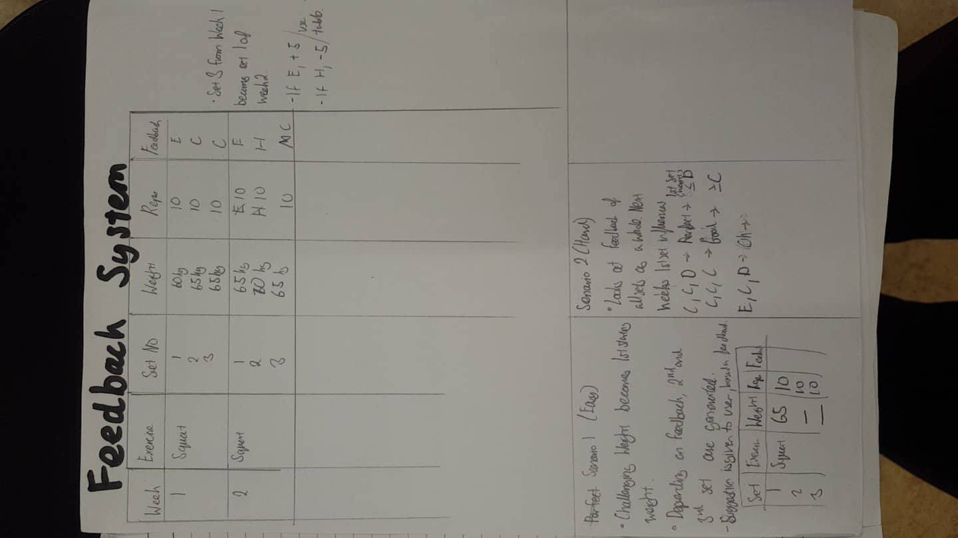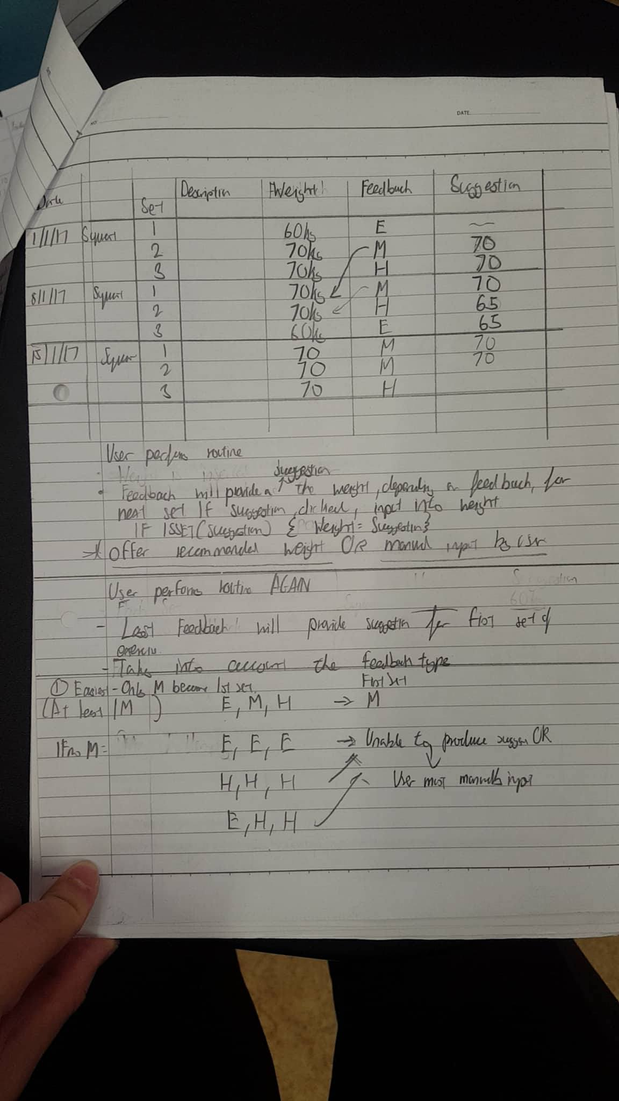

|  |
| --- |
| My plan for my routine and exercise class which included functions such as display routine, and it shows the way the 2 classes are linked. |

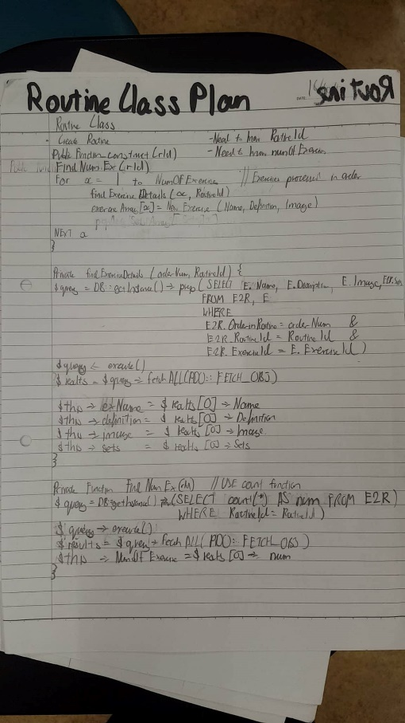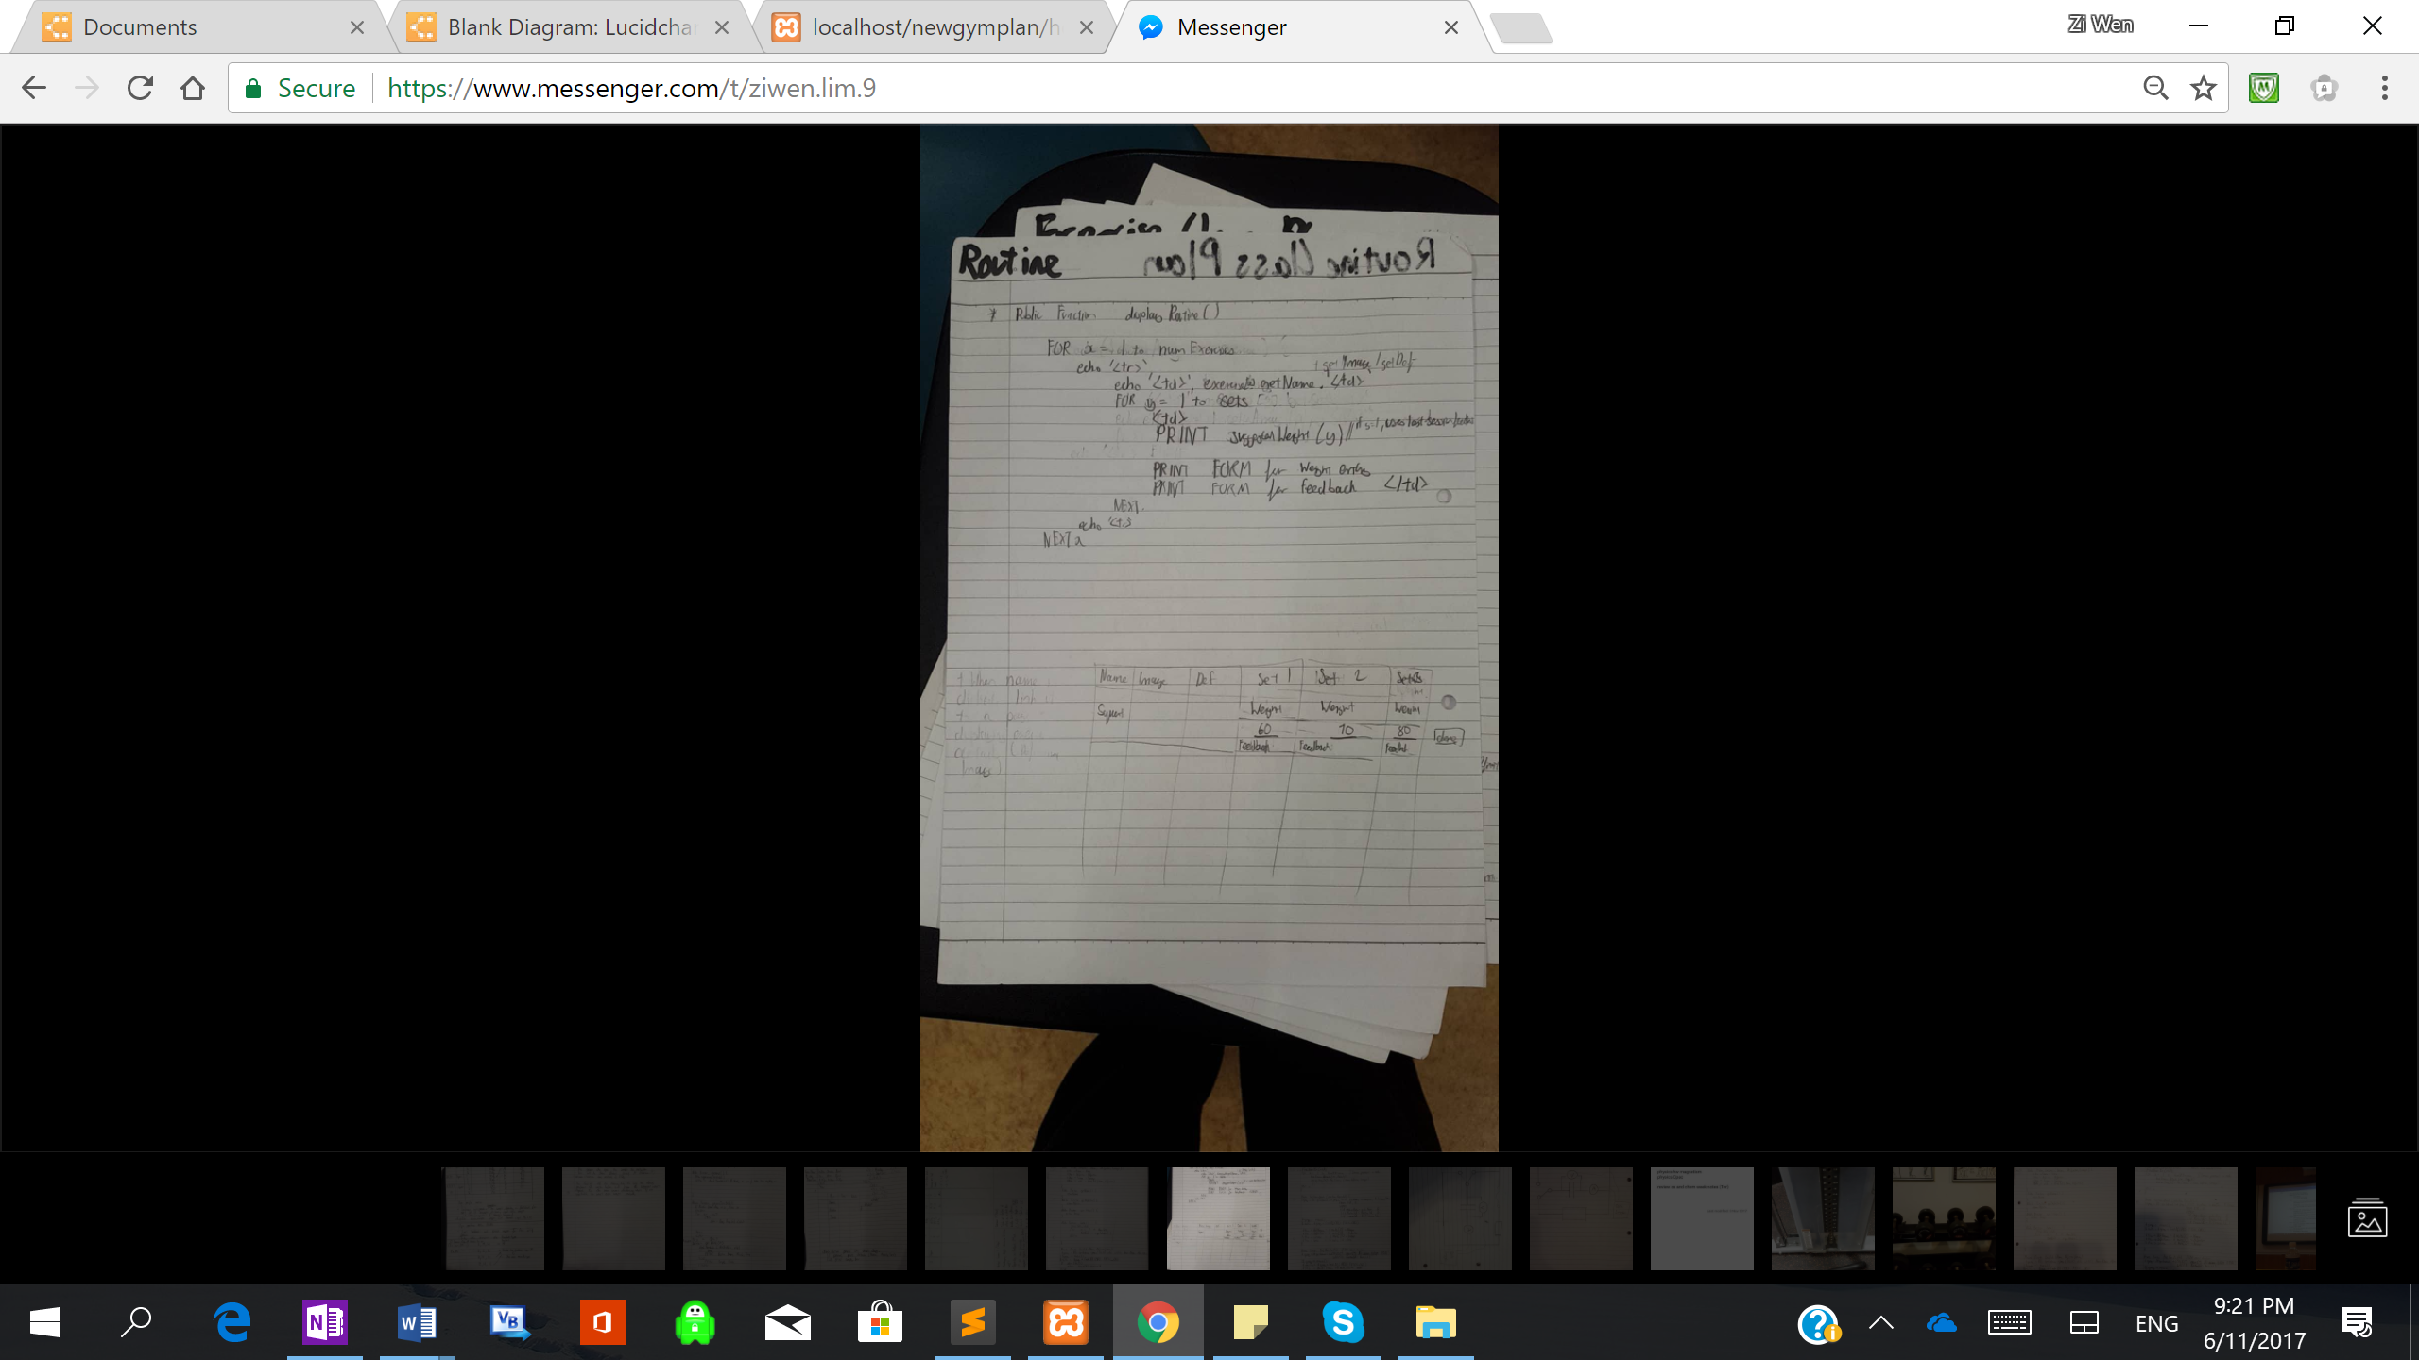

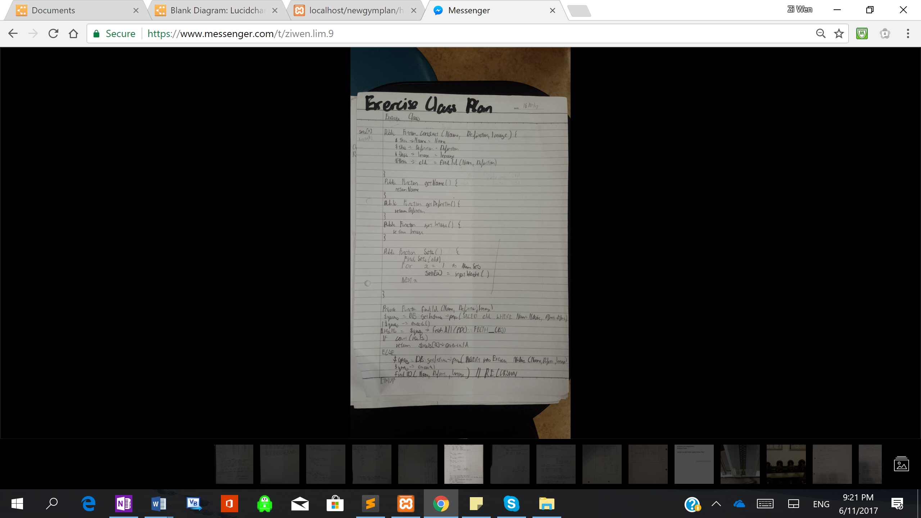

### PHP Implemented Algorithm Design

Please note log of testing evidence is between pages 45 and 68

|  |
| --- |
| **Generate SuggestedWeight()** |
| Log of testing evidence: **Fig 2.3.5** |
| * **WHEN IS IT CALLED:** It will be called inside the retriveRoutine() function, once the system knows that the routine to be called has been performed before by the user. * ***PURPOSE***: Suggest the starting weight for each exercise (set 1 only) * **REQUIRED TABLES:** Exercise2Routine, Feedback, Record   *Examples of data generated*  - Recommended Weight: 50kg  *Highest challenging weight (takes priority), at least 1 “challenging” is present  - Recommended Weight: >20kg, <80kg  *Between highest easy and lowest hard, when “easy” and “hard” are present, but not “challenging”  *assuming no hard is smaller than an easy, if hard<easy print no suggested weight  - >20kg  *higher than smallest easy, when all feedbacks are “easy”  - <80kg  *lower than lightest hard, when all feedbacks are “hard”  Pseudocode  ***Generate SuggestedWeight()***  Foreach (exerciseArray() as exercise){  ChallengingWeight = 0  LowLimit = 0  Upperlimit = 1000000  For x = 1 to Sets //sets obtained via sql  Getfeedback(x, exercise)  If feedback = challenging then //feedback obtained via sql  If ChallengingWeight<Weight  ChallengingWeight = Weight  End If  ELSEIF feedback = Easy  If lowLimit < Weight  LowLimit = Weight // Sets the highest possible easy weight  EndIf  Else //feedback is too difficult  If upperlimit > Weight  Upperlimit = weight // Sets the lowest possible hard weight  EndIf  EndIf  EndIf  Next x  }  If ChalleningWeight <>0  Return ChallengingWeight // Returns the largest challenging weight  ELSEIF lowerLimit < upperLimit THEN  If upperLimit <> 1000000 AND lowerLimit <>0  Return upperLimit & “,” & lowerLimit  Elseif upperlimit <> 1000000  Return “Upper Limit” & upperLimit  Else  Return “Lower Limit” & lowerLimit  Endif  ELSE  Return ‘no suggested weight’  End  Functions Returns a String |
|  |

|  |
| --- |
| **Taking in feedback** |
| **Log of testing evidence: Fig 2.3.2** |
| * **WHEN IS IT CALLED:** When the button for input feedback is pressed, after a set has been performed * **PURPOSE:** To input feedback into feedback table after every set, and details into record table after every completion of an exercise   Each set will need a unique button to identify its own feedback. This can be created using the exerciseId and the set number. This must be generated when routine is outputted  For example: SquatId = “10” Set = “1” concatenate f or w depending on feedback or weight  FeedbackName= Set.SquatId= 1.f.10 (set 1 , feedback, execiseid = 10)  <html>  <form method = ‘post’>  <select name= “1.f.10”  <option value= “1”> Easy </option>  <option value= “2”> Challenging </option>  <option value= “3”> Too Difficult </option>  </select>  <input type='text' name='1.w.10' placeholder='weight' required>  <input type='submit' name='login' value='Login' class='btn'>  </form>  </html>  For orderEx = 1 to LastExerciseOrder //largest OrderInRoutine in E2R table  NumSets = FindNumSets(orderEx) //along with RoutineId, this can identify the Sets in E2R table  Could print exercise table here  Echo exerciseName Details, Image  For sets = 1 to NumSets  Could print exercise table here  Echo Set Number, Suggested Weight (for set 1), input form for weight and feedback  //Check feedback  if (isset($_POST[“$sets.s.$exerciseId”])){  $feedback = $_POST[“$sets.f.$exerciseId”]  $weight = $_POST[“$sets.w.$exerciseId”]  inputFeedback($sets.$exerciseId,weight,feedback)  **implementFeedback($sets.$exerciseId, feedback, $weight)**  if (*sets == NumSets)*{  *//insert details into RECORD table*  }  }  Next sets  Next orderEx  **InputFeedback(**buttonName,$weight,$feedback**){**  $query = $DB::getInstance()->query(“INSERT into FEEDBACK(SetNo, Feedback, Weight) VALUES (setNumber \**first digit of button name* , $feedback, $weight);  $query -> execute();  **}** *same functionality applies for inputRecord |
|  |

|  |
| --- |
| **Implement Feedback** |
| **Log of testing evidence: Fig 2.3.6** |
| * **WHEN IS IT CALLED:** This is called directly after feedback has been inputted * **PURPOSE:** To change the next the intensity of the next set based on the feedback and sets. Generates suggested weight for set 2 and set 3, using feedback from set 1 and set 2 respectively   **Private Function implementFeedback($sets.$exerciseId, feedback, $weight)**   |  |  |  | | --- | --- | --- | |  | Reps<=6 | Reps>6 | | Easy | +5 | +2.5 | | Challenging | 0 | 0 | | Too Difficult | -2.5 | -2.5 | |  |  |  |   IF (feedback = 2){  Return Weight  }ELSEIF(feedback = 1){  If reps <=6  SuggestedWeight = Weight + 5  Elseif reps > 6  SuggestedWeight = Weight + 2.5  Endif  ELSE //feedback is hard  If reps <=6  SuggestedWeight = Weight – 2.5  If reps > 6  SuggestedWeight = Weight + 2.5  EndIf  EndIf    Please Refer to Analysis -> Appendix -> Evidence -> Fig 3.1.1  These images show that most of the gym weights increment by 2.5kg. |

|  |
| --- |
| **Generate TimeTable** |
| **Log of testing evidence: Fig 2.5.3** |
| * **WHEN IS IT CALLED:** Inside the public function construct of the a timetable class * **PURPOSE:** To produce a weekly timetable, showing 7 days of the week, and their corresponding routines on each of those days. It should show Time, Routine Name and Muscles Trained.   \**please note this is code I have already written. The functionality of generate timetable goes across 3 classes.*  **TIMETABLE CLASS**  ***private function generateTimeTable(){***  $this->_daysArray= array('Monday','Tuesday','Wednesday','Thursday','Friday','Saturday','Sunday');  $this->populateDates();  ?>  <table border = '1px'>  <tr>  <?php  for($i='1'; $i<='7'; $i++){  ?>  <th> <?php echo $this->_daysArray[$i-1] ?> </th>  <?php  }  echo "</tr>";  echo "<tr>";  for($i='1'; $i<='7'; $i++){  if ($this->checkRoutinePresent($this->dateArray[$i])){  // print Routine Name, Time Started, Muscle Groups  }else{  // prints empty cell  echo "<td width =250px>";  echo " No Routine ";  echo "</td>";  }  }  echo "</tr>";  echo "</table>";  }  ***private function checkRoutinePresent($date){***  //Checks whether there is routine on a specific date  $uId = $_SESSION['id'];  $query = DB::getInstance()->prep("SELECT * FROM timetable WHERE UserId= '$uId' AND SetDate= '$date'");  $query -> execute();  echo "<br>";  $results = $query->fetchAll(PDO::FETCH_OBJ);  if (count($results)){  // Print Routine Details For That Day  echo "<td width =250px>";  echo "<br>";  echo "Set Time: ".$results[0]->SetTime;  echo "<br>";  echo "Set Date: ".$results[0]->SetDate;  echo "<br>";  $routineId = $results[0]->RoutineId;  $routine = New Routine($routineId); // Association Aggregation  echo $routine->**getDetails();**  echo "</td>";  return true;  }  **private function populateDates(){**  // Gets the date of the specific week day e.g Wednesday = 4th November  $currentDate = $this->getDate();  $day = date('N', strtotime($currentDate));  $this->dateArray[$day]=$currentDate;  for($i=1;$i<$day;$i++){  $daysDiff = $day - $i;  // Subtract Current Date and days Diff  $newDate = date('Y-m-d',strtotime('-'.$daysDiff.'day', strtotime($currentDate)));  $this->dateArray[$i] = $newDate;  }  for($i = $day + 1; $i<=7; $i++){  $daysDiff = $i - $day;  // Add Current Date and days Diff  $newDate = date('Y-m-d',strtotime('+'.$daysDiff.'day', strtotime($currentDate)));  $this->dateArray[$i] = $newDate;  }  }  **ROUTINE CLASS**  ***public function getDetails(){***  // Gets Routine Name, Muscles Trained,  echo "Name of Routine: ".$this->_name;  $muscleString = $this->getMusclesTrained();  // Turn string seperated by commas into array  $arrayMuscle = explode(',', $muscleString);  // Make sure all values in array are unique, so only 1 muscle of each type can be outputted  $arrayMuscle = array_unique($arrayMuscle);  echo "<br>";  echo "Muscles Trained: ";  echo "<br>";  foreach($arrayMuscle as $muscle){  $query = DB::getInstance()->prep("SELECT Name FROM muscle WHERE MuscleId='$muscle'");  $query -> execute();  $results = $query->fetchAll(PDO::FETCH_OBJ);  echo $results[0]->Name;  echo "<br>";  }  }  **public function getMusclesTrained(){**  // using muscle 2 exercise, input the muscles trained into the array , ensuring no repeats  // each exercise class holds the property of muscles trained  $count = 0;  foreach($this->_exerciseArray as $exercise){  $this->musclesTrained[$count] = $exercise->**getMuscles();** // Array holding a string of muscles  $count = $count + 1;  }  $muscleString="";  for($i=0; $i<$this->_numOfExercise;$i++){  $muscleString = $this->musclesTrained[$i].$muscleString;  }  // Remove last comma  $length = strlen($muscleString);  $muscleString = substr_replace($muscleString,"",$length-1,$length);    return $muscleString;    }  **EXERCISE CLASS**  ***public function getMuscles(){***  $eId = $this->_eId;  $query = DB::getInstance()->prep("SELECT * FROM muscle  INNER JOIN muscle2exercise on muscle2exercise.MuscleId = muscle.MuscleId  WHERE muscle2exercise.exerciseId='$eId'  ");  $query->execute();  $result_array = $query->fetchall(PDO::FETCH_ASSOC);  $stringMusclesId = "";  foreach($result_array as $result){  $stringMusclesId = $result['MuscleId'].','.$stringMusclesId;  }  return $stringMusclesId;  } |

## SQL Queries and Explanations

|  |
| --- |
| **Purpose:** (aggregate sql function) Finds number of exercises in 1 routine |
| Finds the number of exercises belonging to 1 specific routine. It looks through the exercise2routine table, and checks for records with matching routine Id, the query then counts the number of matches. |
| **Query** |
| **SELECT COUNT (ExerciseId) as num FROM exercise2routine WHERE RoutineId = ?** |
| **Testing**  *Please refer to Log Of Testing on 20/10/17 on Page 6* |

|  |
| --- |
| **Purpose:** Checks if Routine performed before |
| Checks if routine has been done before, and organises it so that result [0] will have the most recent date. The most recent date the user has performed the exercise, is needed to determine whether the date performed was 31 days or less ago, if so it would provide suggestions for starting weight. |
| **Query** |
| **SELECT DatePerformed FROM record WHERE RoutineId = ? AND UserId = ? GROUP BY DatePerformed DESC** |
| **Testing** |

|  |
| --- |
| **Purpose:** Populates exercise class’s properties |
| The query populates the properties of a exercise belonging to a specific routine. It retrieves the rests period, sets, reps, and order in routine. |
| **Query** |
| **SELECT * FROM exercise2routine WHERE ExerciseId = ? AND RoutineId=?** |
| **Testing** |

|  |
| --- |
| **Purpose:** (cross table parametrised SQL) Finds the muscles used per exercise |
| This sql uses a cross table paramterised SQL, to search for the muscles linking to a specific exercise |
| **Query** |
| **SELECT * FROM muscle**  **INNER JOIN muscle2exercise.MuscleId=muscle.MuscleId**  **WHERE muscle2exercise.exerciseId= ? *(exerciseId)*** |
| **Testing**  *Please refer to log of testing evidence, on 29/10/17, in* ***fig 2.5.2*** |

## Data Structures

**Arrays**

* Each routine class has an array of exercise classes. Each exercise is instantiated in the routine class; hence, this is composition aggregation.
* An array of dates is stored to produce the timetable

**Queue**

* Priority Queue: After searching for routine, results can be sorted in order of priority, e.g relevance, rating, date etc. This can be done using a recursive merge sort. Then the system can use recursive binary search, to find the correct routine.

**Stack**

* In the Log Class, a stack is used to store the dates of performed routines for a single user. The sql function will return all the dates in ascending order, with the most recent routine at the end of the array. The last data item is then popped first, in the log class. Moreover, when a more recent routine is performed, it is pushed to the back of the stack, but is popped first when log class is called.

## Design Pre - Implementation

### CRC Cards – Creating Classes

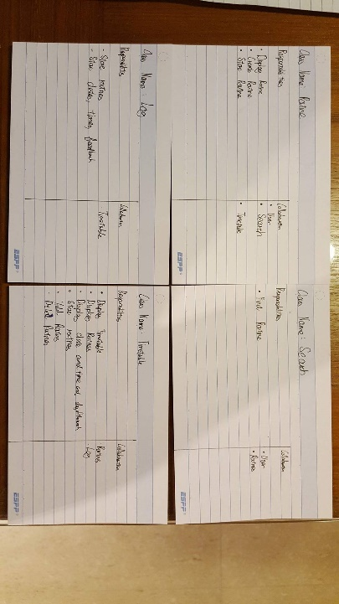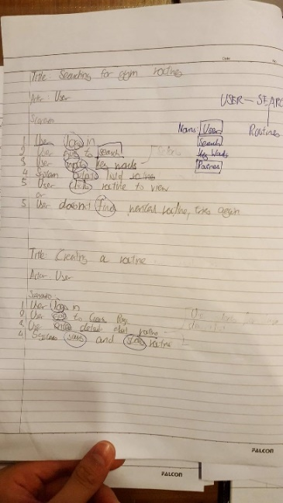

## Final Design User Interface and Explanation

### Log In Page

|  |
| --- |
| My log in page will allow users to input their login details securely. Password is of type ‘password’, so people cannot physically see the user typing in their password.  The log in page also tells the user whether the email or the password is wrong, showing different error messages.  There is a register button brining first time users to a register page. |

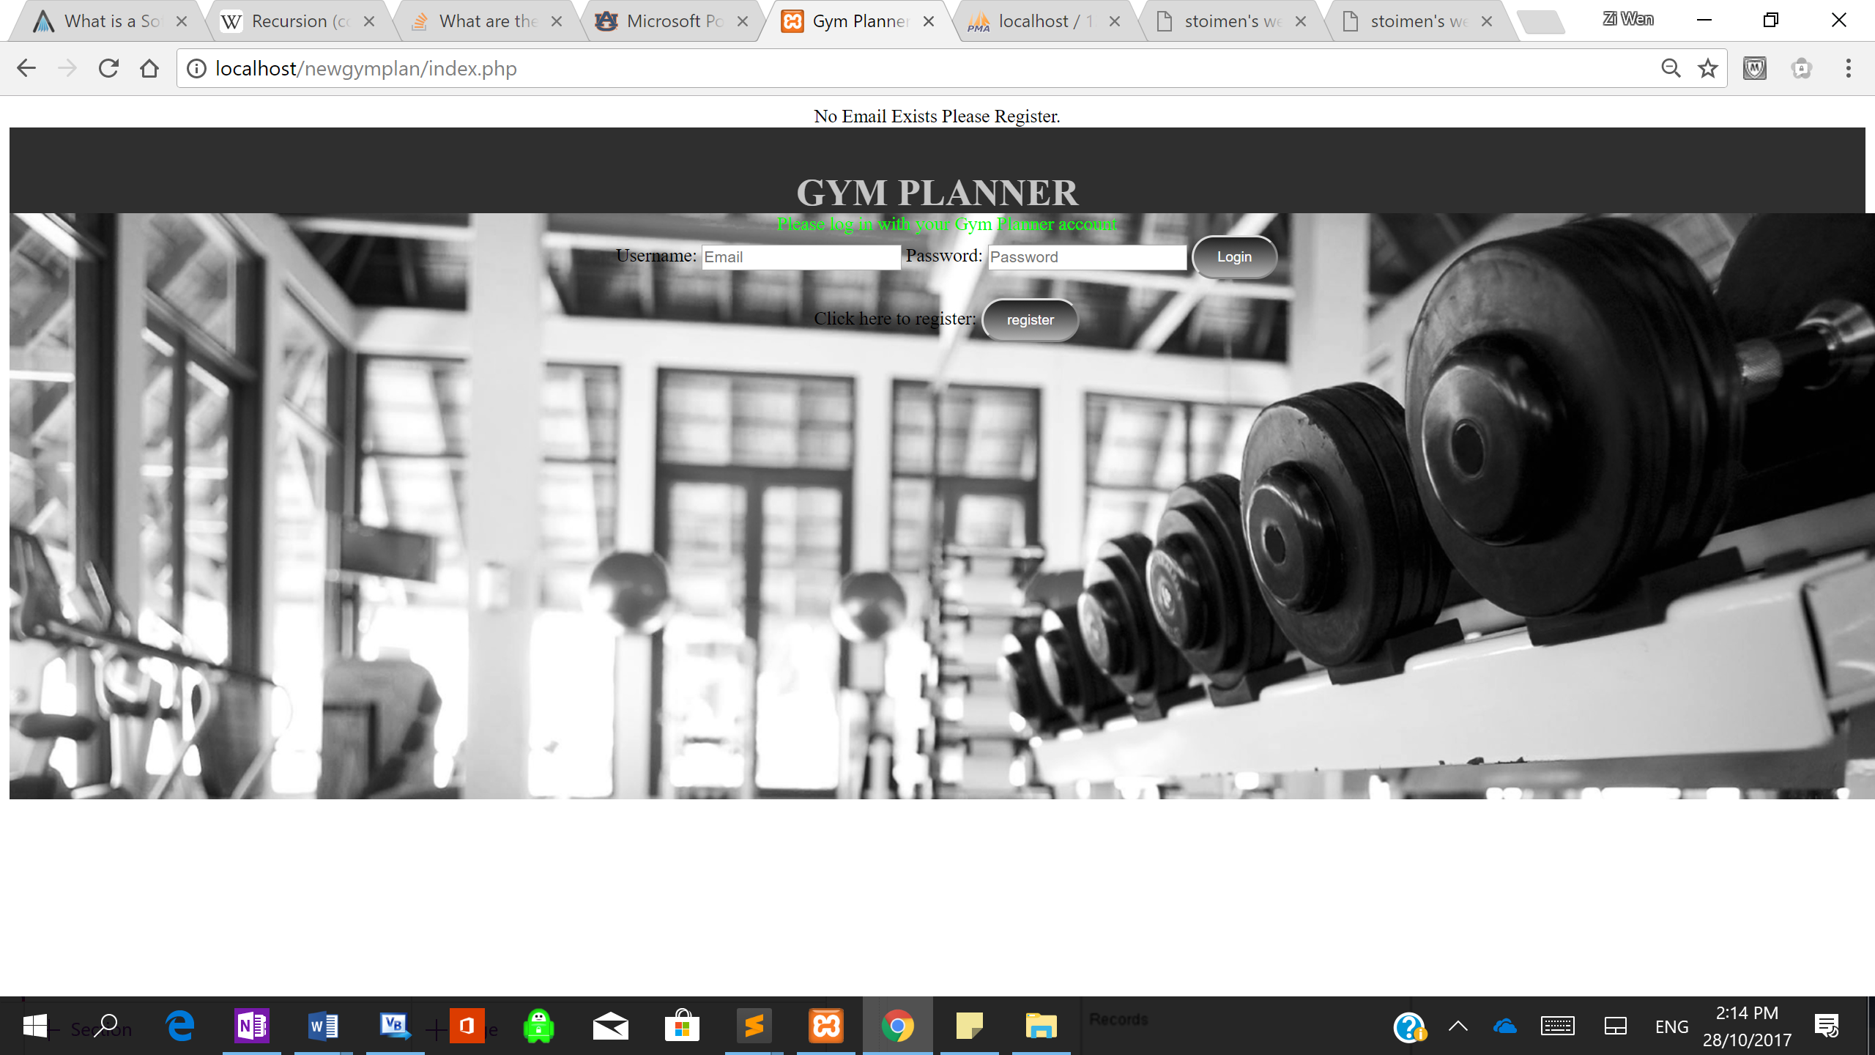

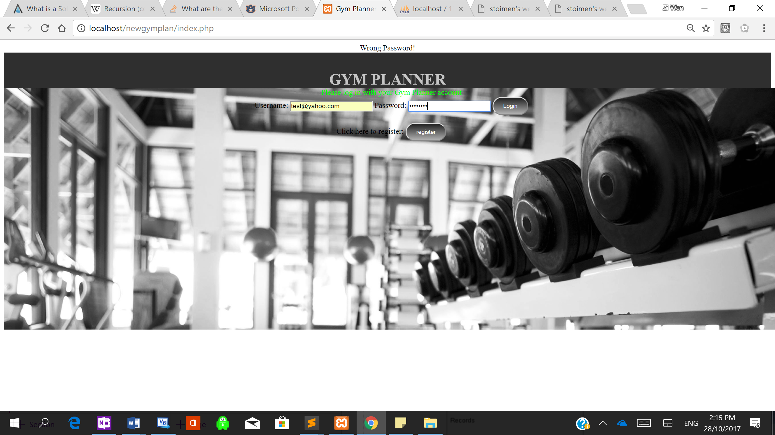

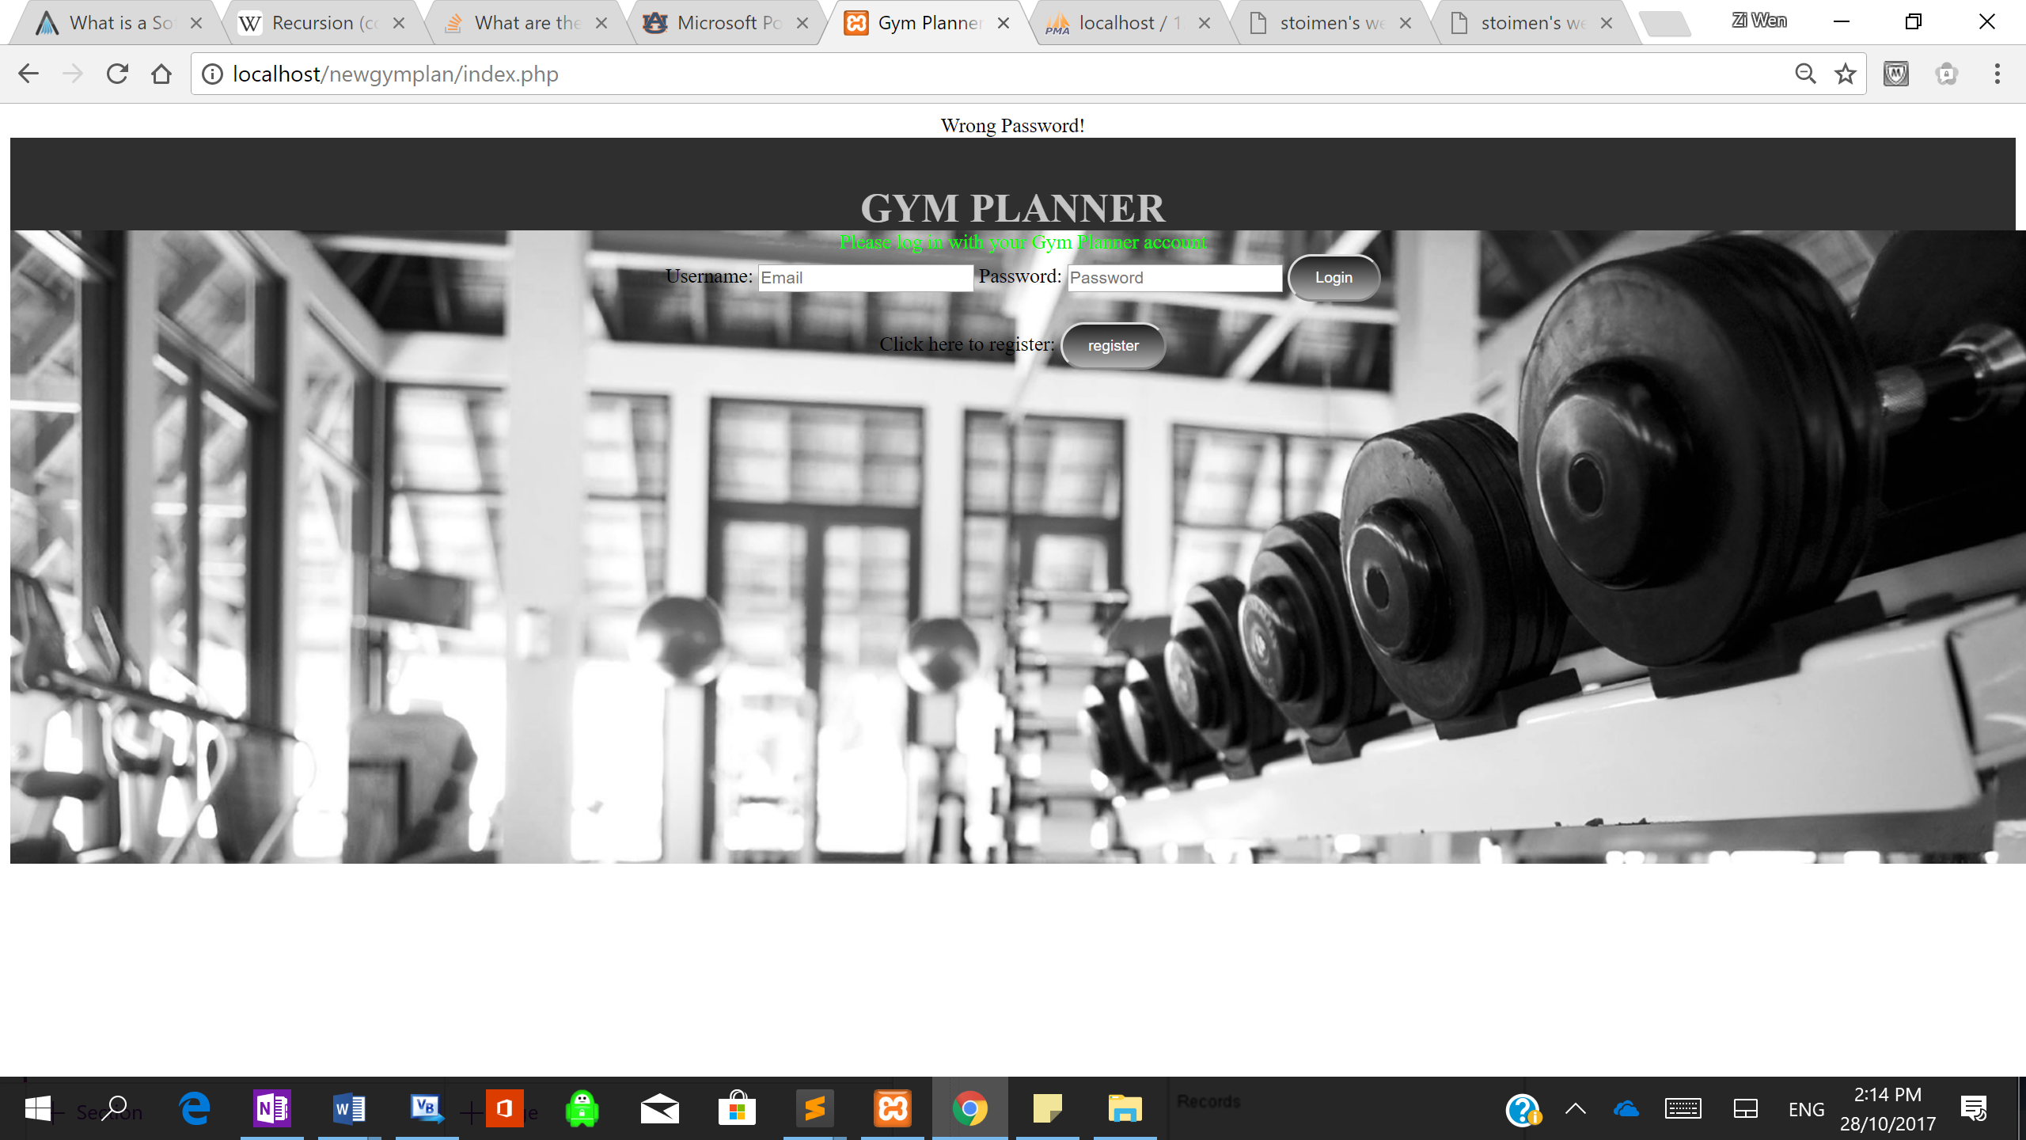

### Register Page

|  |
| --- |
| The register page provides a form for users to input their details. Their email and password will form the log in details. |

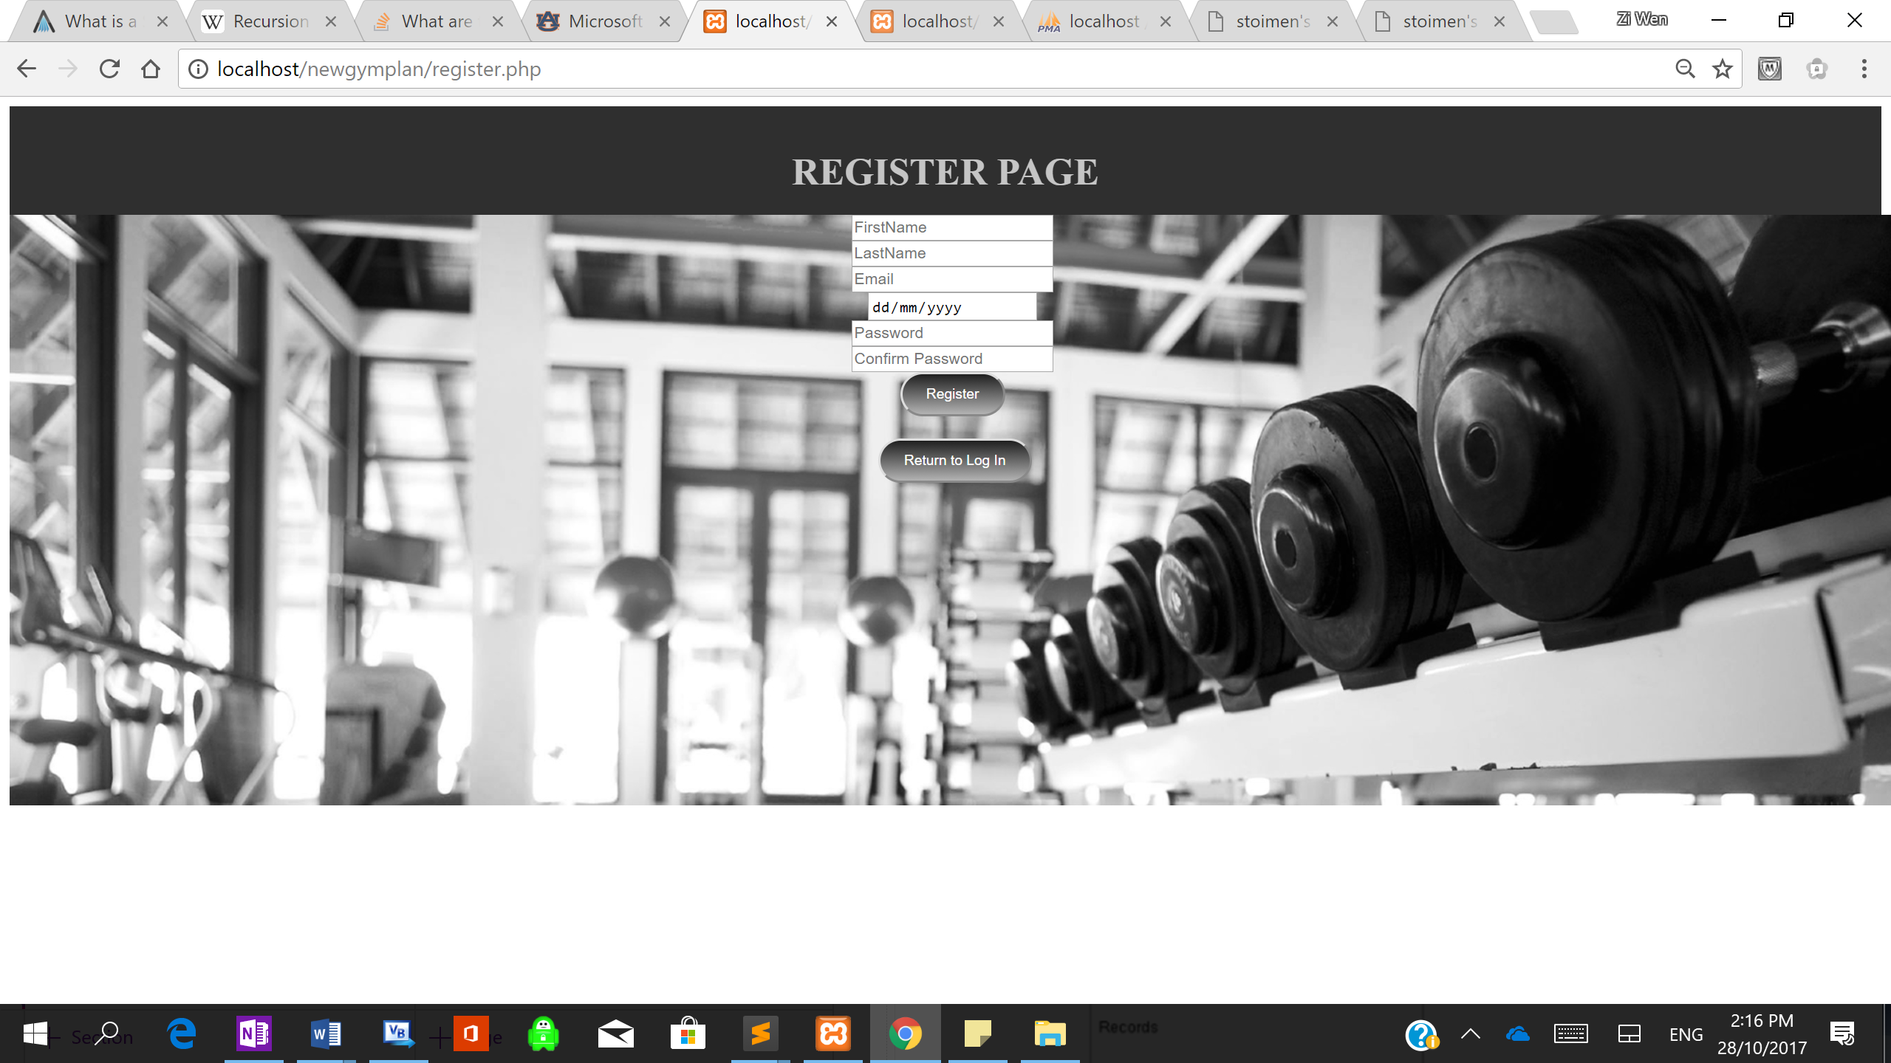

|  |
| --- |
| The routines will be displayed as so, each exercise and its information will be displayed in a table. The submit buttons will be in a table below. The suggested starting weight will be present only if the user has performed the routine before.  The routine will also include the name of the creator, when it was last performed and the name of the routine.  Submit buttons are vital, since they input the users feedback into the database. The submit, feedback and weight inputs are all unique, this is so the system can identify which button has been pressed.  I plan to add a timer at the top of the page to time how long it takes to do workout. |

### Routines

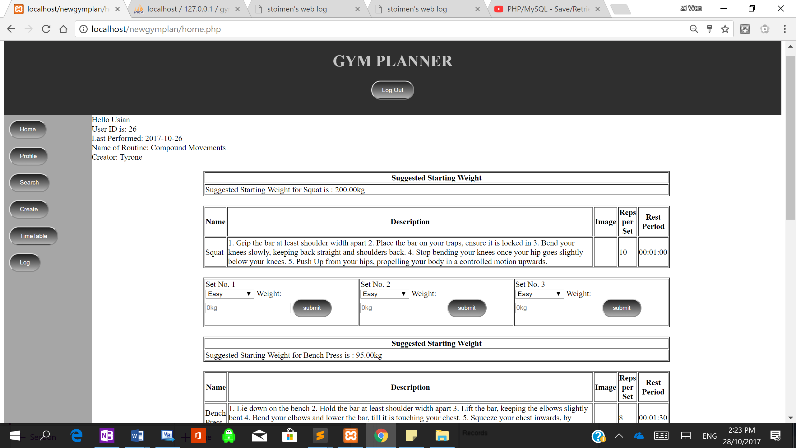

|  |
| --- |
| After Each Set, the system will provide the user with a suggested weight depending on their feedback, like so.  A drop down list will give 3 suggestions which the user must complete in order to get his or her suggested weight. |

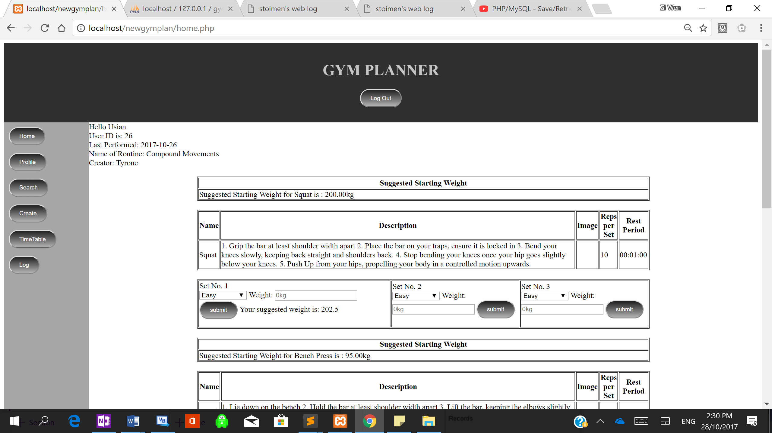

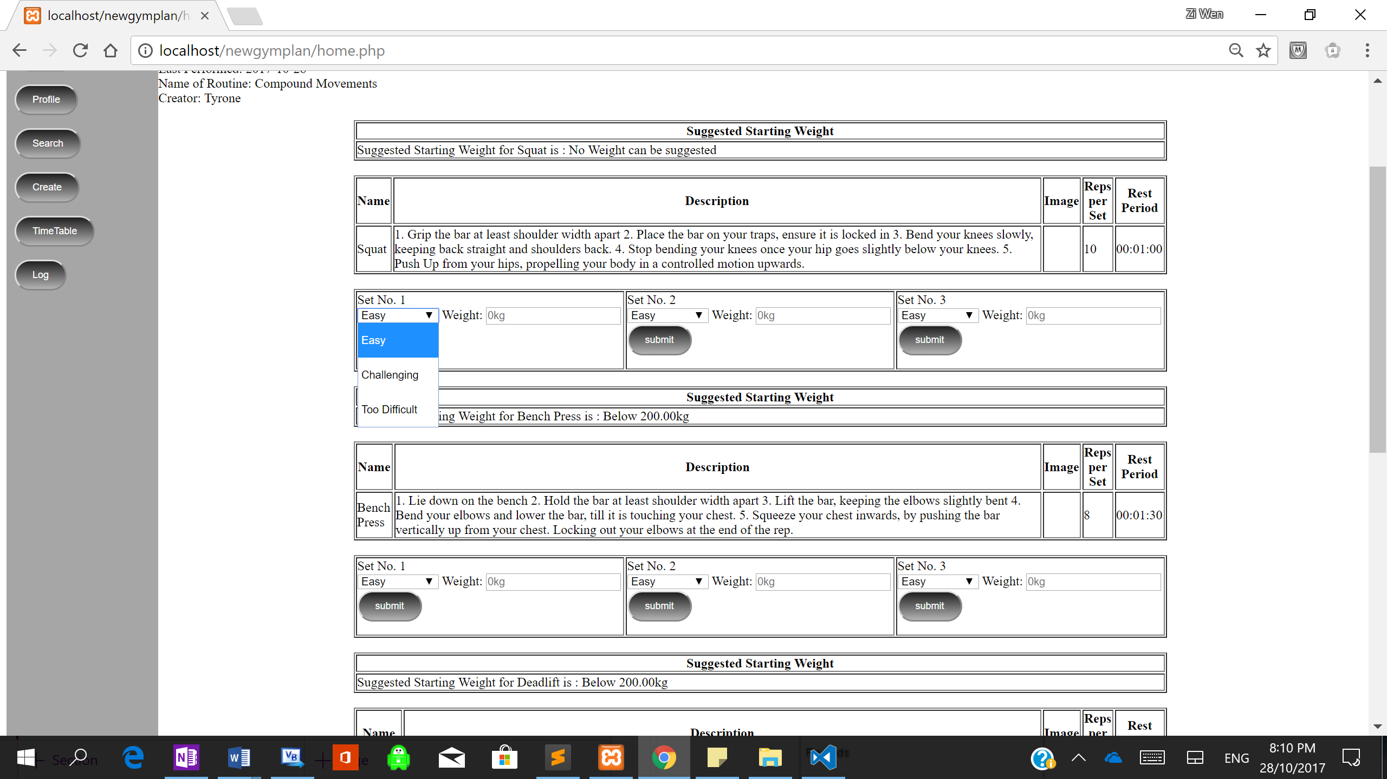

### Profile

|  |
| --- |
| Profile Page will display the basic information belonging to a user this includes: First Name, Last Name, Date of Birth and their Profile Picture.  In this page they will be able to change their password and their profile picture if they wish.  Side Bar, included in every page, allows for easy navigation between pages. |

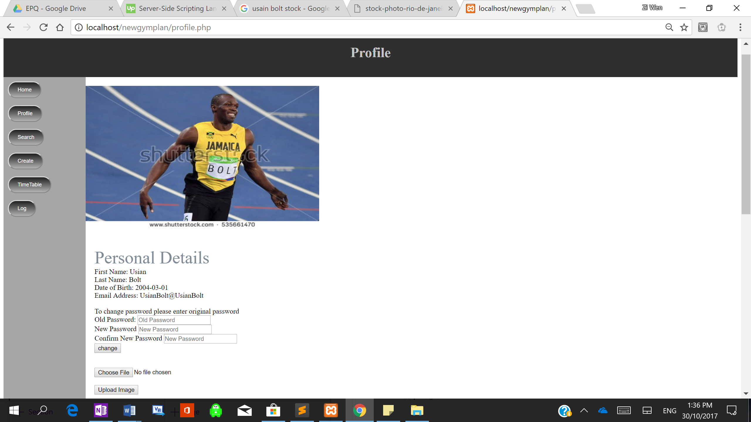

### Timetable (in development)

|  |
| --- |
| This is a basic template for my timetable. In each day, if there is a routine, it will output the Time, Date, Name of Routine and the Muscles trained in the routine, my system will ensure only 1 type of muscle is printed once.  Below there will be a button to add Routines to specific days in the week. |

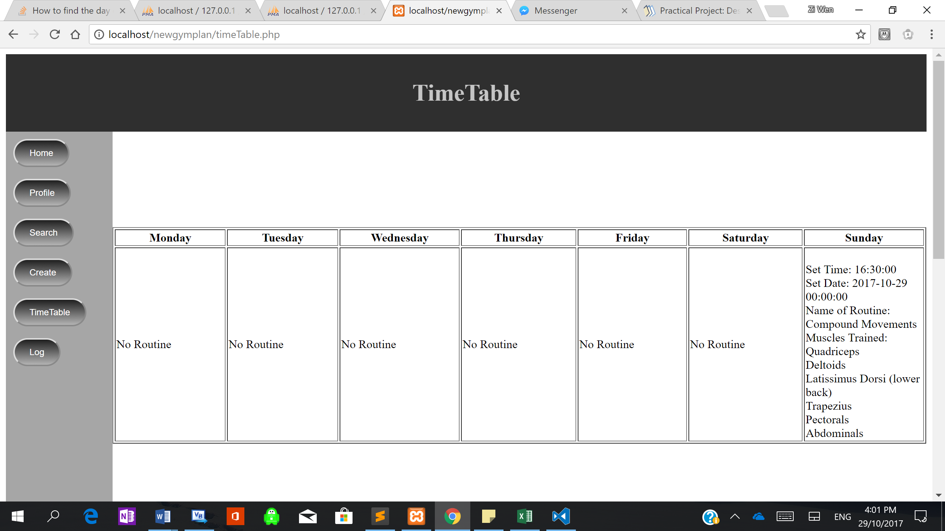

### Search

|  |
| --- |
| In the search page, a user can search for a routine based on the Name of Routine, Creator and Muscles. In addition, they can sort their results in order of rating or last performed date.  The screenshot shows how the user interface will look like, pre-search and the display of results. |

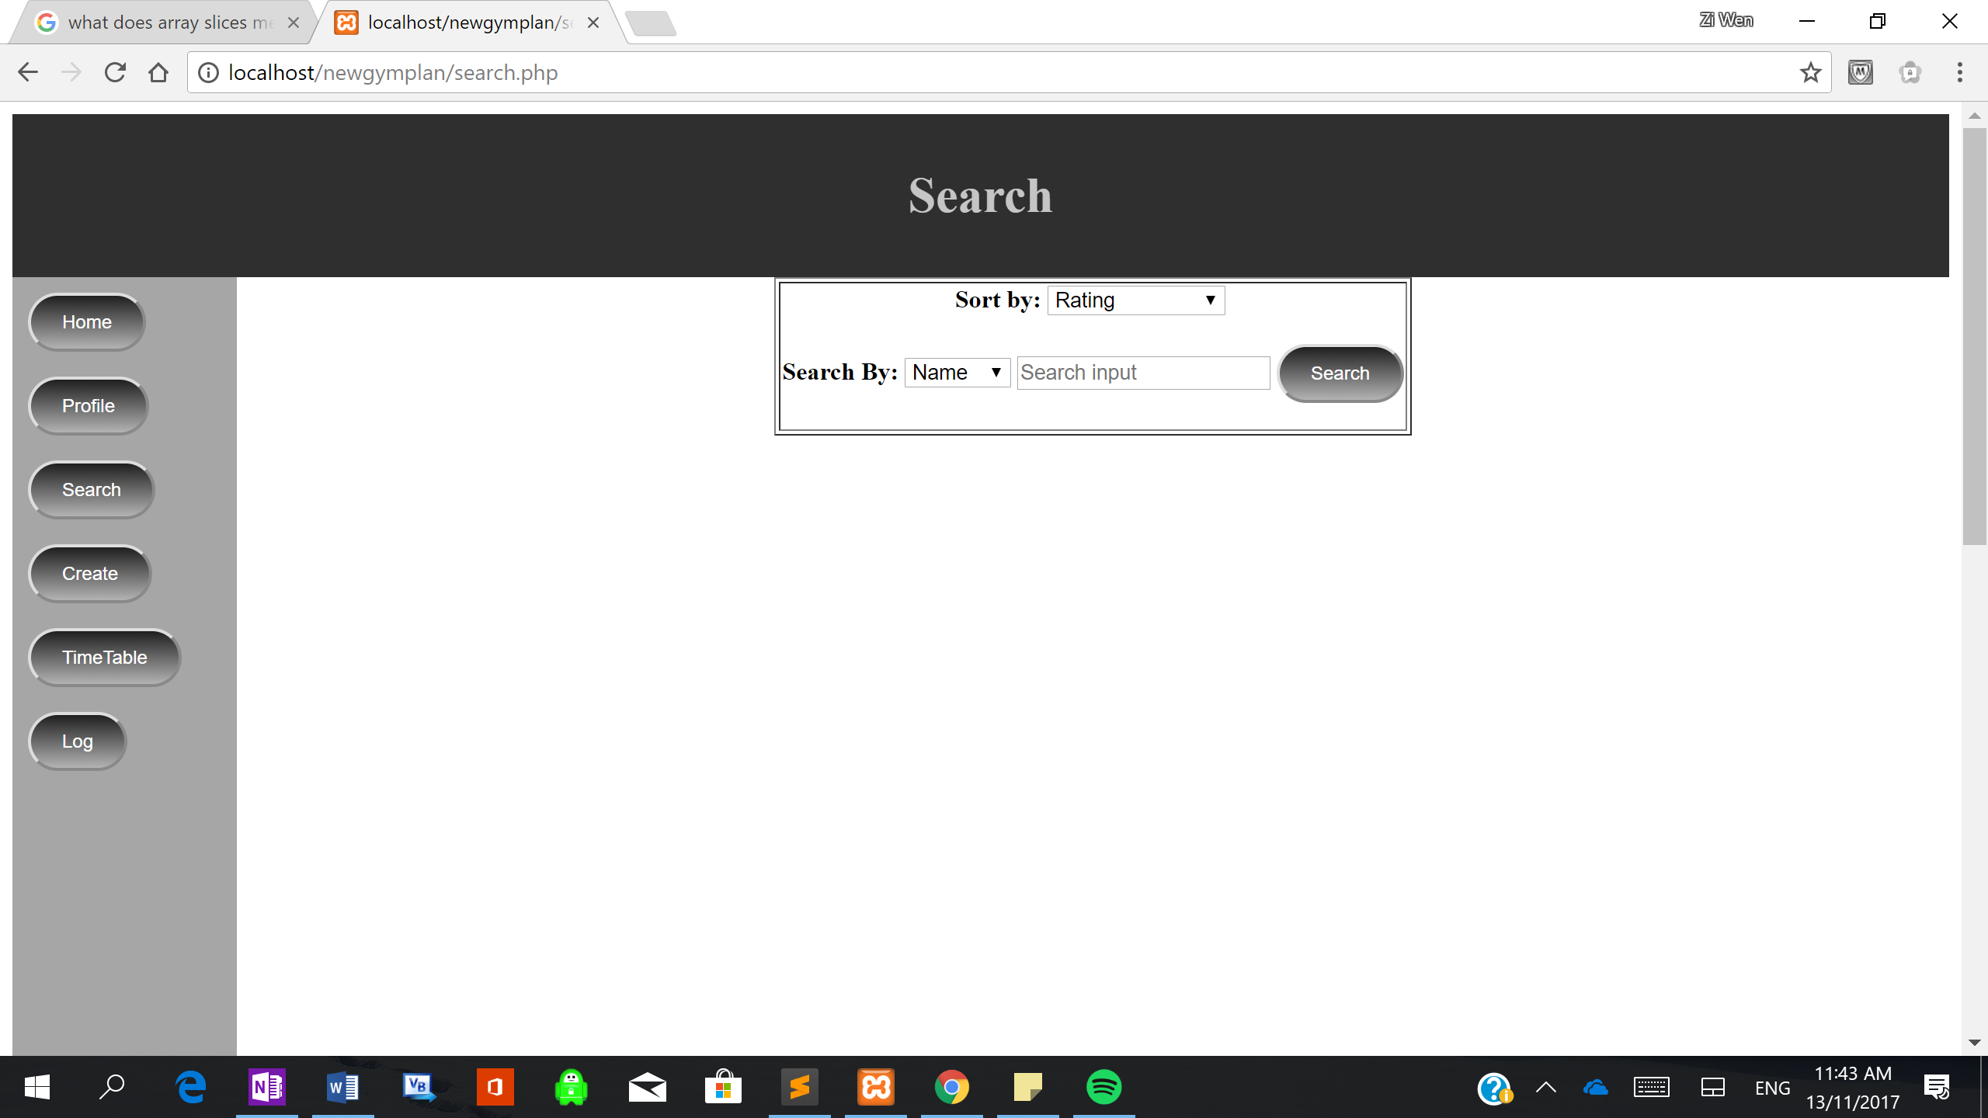

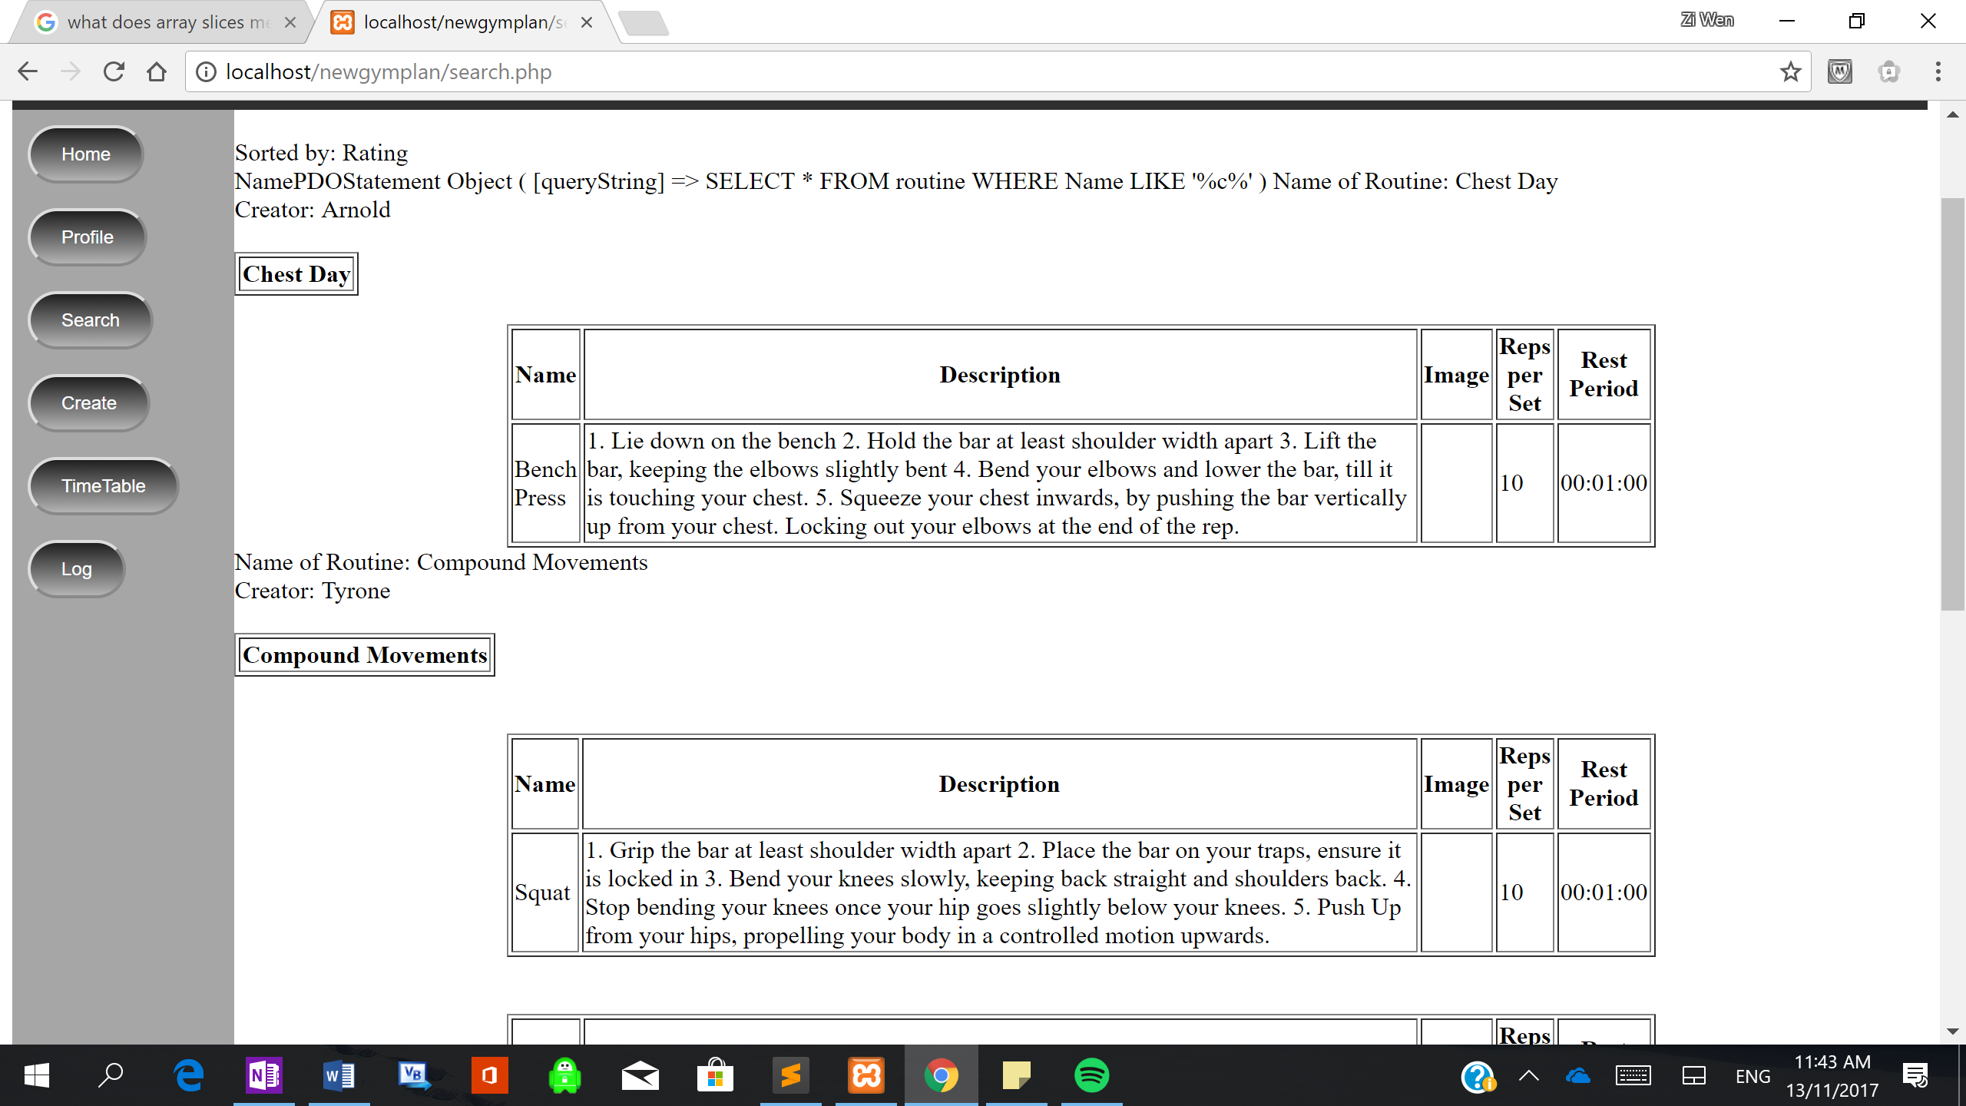

## Naming Conventions

|  |  |  |
| --- | --- | --- |
| Type | Naming Convention | Example |
| Class | Name starts with a capital | Class.php |
| Normal Page | Name starts with lower case | home .php |
| Table name | Lower case (automatic by mySQL) | table |
| Table attributes | Capital Letter for start of every word, no spaces | RoutineId  RestInBetween |
| Method Names | Camel Case | generateTimetable() |
| Variable Names | Camel Case | newRoutine |

## Hardware Selection / Design

My website will be hosted from my computer, because I am using php a server-side scripting language, my computer will act as the central server, storing and manipulating the data.

|  |  |
| --- | --- |
| **Hardware** | **Description** |
| Mouse | Mouse will help navigate through the website by clicking buttons. |
| Keyboard | This will allow them to input ASCII characters into the website. |
| Visual Display Unit | A medium to display human readable data. This will allow the user to see their own inputs into the website and the website’s outputs. |
| Hard Disk Drive / Solid State Drive | Secondary storage used to store large amounts of data, it is non-volatile, so data is stored indefinitely. |

My gym app should work primarily on mobile devices, this is because users are more likely to bring their phones to the gym as they are much more portable. A phone will be easy to carry and will allow the user to quickly and efficiently input their data during the workout. The smart phone will be able to output the necessary data in the given screen size. Below, shows a display of what my gym app should look like in a phone.

## Visual Design on Phone (Nexus 5X)

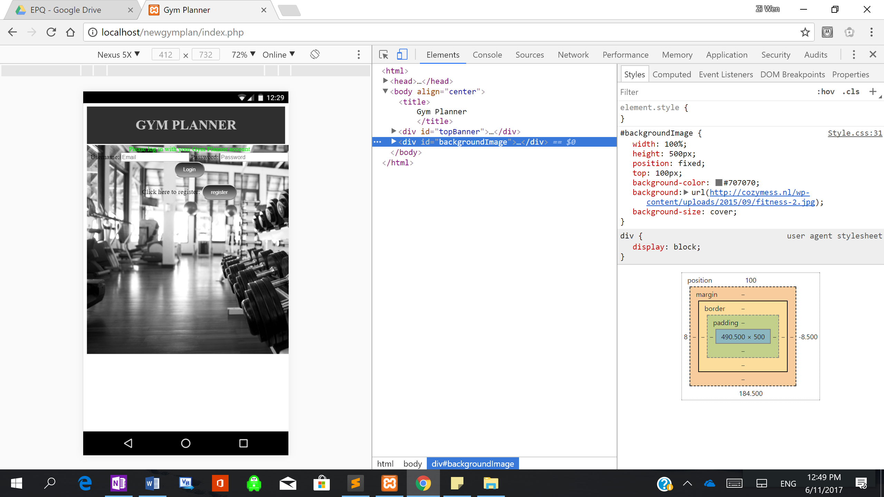

## System Security

For my system to be secure, my users’ data must be manipulated and stored in a secured manner. I have done this through several techniques. I have firstly set a password and username to my database; hence the server will require the correct combination of password and username to access mysql database.

The server, which is my computer, has anti-malware software installed, such as McAfee, this will run frequent checks and remove any malicious software, that could present a threat to the security of my website.

In my program, I have taken several precautions to keep information and user data safe. I have prevented the threat of SQL injections by doing bindValue() and using ? in SQL statements, rather than directly inserting the variable in the statement. The question mark means that whatever is put in it, will be read as only data, and cannot be accidently be read as an SQL statement. An SQL injection, is an SQL statement put in by a user during an input, if run successfully the user could have full access to the database. I have also used the POST function, rather than the GET function, when retrieving data from a form; the reason being that the GET function shows the data in the URL, where the POST does not.

In addition, to improve security of user data I have encrypted their password using a hash. Hashing is a 1 way function that generates a unique value, using a key. In my system, when the user creates an account, a random 32 character string is made to hash with their password, thus even if 2 users share the same password their hash will still be different. In the case when the database is compromised, the hacker will not get the users true password maintaining the security of user’s accounts.

When a user logs out, the session is destroyed to ensure that no data is left in the session. In addition, on every page the system checks the session to see if there is a user id, if it is absent, the user is automatically logged out; this prevents any user from directly trying to go into someone’s account without logging in (e.g if someone tries to go back a webpage or access someone’s history).

## Integrity of Data

In the database, I have ensured that the tables are in 3rd normal form: no data redundancy, no repeating groups, no non-key dependencies and no partial key dependencies. Reducing data inconsistency, where when 1 piece of data is stored in several places, will reduce the update anomalies from occurring.

To ensure the integrity of data, I have only allowed users certain functionality and access rights, which will make sure no user can access unauthorised information. For example, users can insert routines into timetables, but cannot insert routines into other people’s timetables.

To improve user experience, I have added drop down list and have included several compulsory fields, so the correct type of data is always entered into the system. In addition, when user’s change their password, they must enter their old password and then enter their new password twice, this reduces the chance of human error and incorrect information being inserted into the database.

Thus, my program will comply with the Data Protection Act, which states that: data must be lawfully processed and for its intended purposes, adequate (not excessive, so not storing unnecessary information), accurate and secure.